Gill- Montague Regional School District
Pupil Services Office
35 Crocker Ave., Turners Falls, MA 01376
(413) 863-7507 Fax (413) 863-3296
On the web: www.gmrsd.org/

“Challenging and Supporting Every Student.”

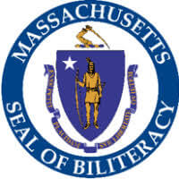
Seal of Biliteracy Application

STUDENT INFORMATION
Student Name: _____________________________________________________________
Parent/Guardian: ___________________________________________________________
Primary phone: ____________________________ Grade: _________________________

FOR WHAT PARTNER LANGUAGE ARE YOU APPLYING?

Partner language (other than English):______________________

Student signature: ______________________________ Date: ____________________
Parent/ Guardian signature: ________________________ Date: _____________________

If you are interested, please submit an application to Ms. Fortin in guidance by May 10, 2019. We will be offering the partner language assessment in May during the school day, free of charge for any interested seniors.

